BLACK RABBIT KIDS MENU

$15 for a drink, meal and dessert
12 years old and under
Choose one juice:
- Apple juice
- Orange juice
Choose one meal:
- Fish and chips – grilled or battered
- Chicken nuggets and chips
- Sausages with mash and peas
- Pizza – with ham and cheese
- Cheese burger and chips
Choose one dessert:
- Chocolate ice cream sundae
- Berry ice cream sundae
Colour in
- Colour in the picture on the back
- Fill out your details
- put in the colouring competition box
- go in the draw to win a $5 voucher
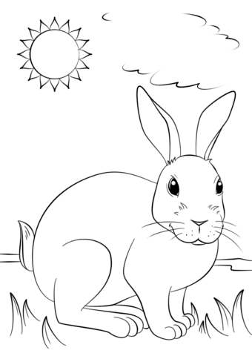

NAME: _______________________________

AGE: _______________

ADDRESS: ____________________________

_____________________________________

